

Pune District Education Association’s
Shankarrao Ursal College of Pharmaceutical Sciences and Research Centre, Kharadi, Pune-14.
------------------------------------------------------------------------------------

REPORT
FOR CRICKET EVENT
(Annual Sports A.Y. 2025-26)

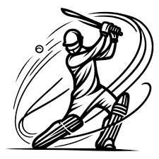

Pune District Education Association’s
Shankarrao Ursal College of Pharmaceutical Sciences and Research Centre, Kharadi, Pune-14.
------------------------------------------------------------------------------------
SCHEDULE
[Academic Year 2025-2026]

Boys Cricket

Sr. No. | Date | Time | Team
1 | 01/01/2026 | 9.30 am to 11.30 am | F.Y. B.Pharm Vs Final Year B. Pharm (A)
2 | 01/01/2026 | 11.30 am to 1.30 pm | T.Y. B.Pharm Vs D. Pharm (B)
3 | 02/01/2026 | 9.30 am to 11.30 am | S.Y. B.Pharm Vs M. Pharm (C)
4 | 03/01/2026 | 2.30 pm to 4.30 pm | Semifinal -1 (Winner of A Vs Winner of B)
5 | 05/01/2026 | 9.30 am to 11.30 am | Semifinal -2 (Winner of C Vs loser of semifinal-1)
6 | 06/01/2026 | 9.30 am to 12.30 pm | Final (Winner of semifinal 1 Vs Winner of semifinal 2)

Dr. Vipul Dhasade Mr. Nitin Neharkar Mr. Vikram Veer
Sports Incharge Co-ordinator Co-ordinator

Dr. Ashok Bhosale
Principal

Pune District Education Association’s
Shankarrao Ursal College of Pharmaceutical Sciences and Research Centre, Kharadi, Pune-14.
------------------------------------------------------------------------------------
Rules for Cricket
[Academic Year 2025-2026]

1) Respective Cricket team should be present on cricket ground 15 minutes prior as per the
above mentioned schedule. Team remaining absent at right time for their match will be
disqualified. Any requests for change of match timings will not be entertained.
2) A player who has played in one team is not allowed to play in another team.
3) On-field Umpire’s decision would be the final one.
4) Each Match will be of Total 8 overs out of which First 2 overs are mandatory power play.
5) Final match will be of 10 overs out of which First 3 overs are mandatory power play.
6) Only 2 players can field outside the 30 yard circle during power play over’s.
7) All players of the team should follow college discipline. Any misbehavior by the player/s
would effect disqualifying action.
8) Only one player substitution is allowed in entire match for each team
9) Only one bowler is allowed for delivering maximum 3 overs
10) In matches if a tie happens, Super over would be held.
11) Year down (YD) student is not allowed to play in respective class team
12) Rules for super over :
i) The team batting second in the match will bat first in the Super Over.
ii) 3 Batsmen from each team can bat and 1 bowler from each team will bowl
iii) Entire fielding unit is allowed to field
iv) Super over is tied, below rule applicable :
Least Number of wickets fallen (main + super over)

Dr. Vipul Dhasade Mr. Nitin Neharkar Mr. Vikram Veer
Sports Incharge Co-ordinator Co-ordinator

Dr. Ashok Bhosale
Principal

Pune District Education Association’s
Shankarrao Ursal College of Pharmaceutical Sciences and Research Centre, Kharadi, Pune-14.
------------------------------------------------------------------------------------
Cricket Boys
(A.Y.2025 -2026)
LIST OF RANKERS
1. WINNER TEAM:
Sr.No. | Name of the Class
1. | Final Year B. Pharm

2. RUNNER TEAM :
Sr.No. | Name of the Class
1. | Third Year B. Pharm

3) Best Batsman : Mr. Harshad Pathare (Class : T.Y. B. Pharm)
4) Best Bowler : Mr. Pranav Kanade (Class : S.Y. B. Pharm)
5) Man of the Match : Mr. Mayur Ransingh (Class : Final Year B. Pharm)

Dr. Vipul Dhasade Mr. Nitin Neharkar Mr. Vikram Veer
Sports Incharge Co-ordinator Co-ordinator

Dr. Ashok Bhosale
Principal

Pune District Education Association’s
Shankarrao Ursal College of Pharmaceutical Sciences and Research Centre, Kharadi, Pune-14.
------------------------------------------------------------------------------------
Cricket Girls
(A.Y.2025 -2026)
LIST OF RANKERS
1. WINNER TEAM:
Sr.No. | Name of the Class
1. | Third Year B. Pharm

2. RUNNER TEAM :
Sr.No. | Name of the Class
1. | First Year B. Pharm

3) Best Batsman : Ms. Anushka Dhaygude (Class : F.Y. B. Pharm)
4) Best Bowler : Ms. Shravani Wable (Class : T.Y. B. Pharm)
5) Man of the Match : Ms. Roshni Purohit (Class : T.Y. B. Pharm)

Dr. Vipul Dhasade Ms. Shubhangi Karkhile
Sports Incharge Co-ordinator

Dr. Ashok Bhosale
Principal

Pune District Education Association’s
Shankarrao Ursal College of Pharmaceutical Sciences and Research Centre, Kharadi, Pune-14.
------------------------------------------------------------------------------------
Glimpses of Cricket
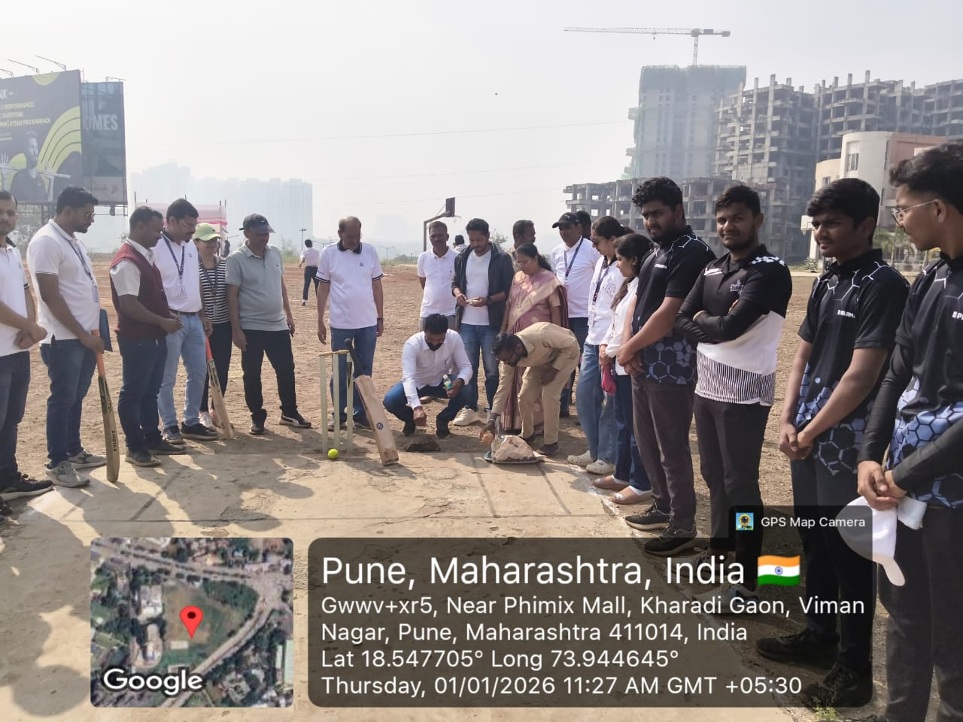
Chief guest Mr. Arvind Salve (Founder –CFC International organization, Pune) and
Principal Dr. Ashok Bhosale during ingauration of the cricket event .

Dr. Vipul Dhasade Mr. Nitin Neharkar Mr. Vikram Veer
Sports Incharge Co-ordinator Co-ordinator

Dr. Ashok Bhosale
Principal

Pune District Education Association’s
Shankarrao Ursal College of Pharmaceutical Sciences and Research Centre, Kharadi, Pune-14.
------------------------------------------------------------------------------------
Glimpses of Cricket
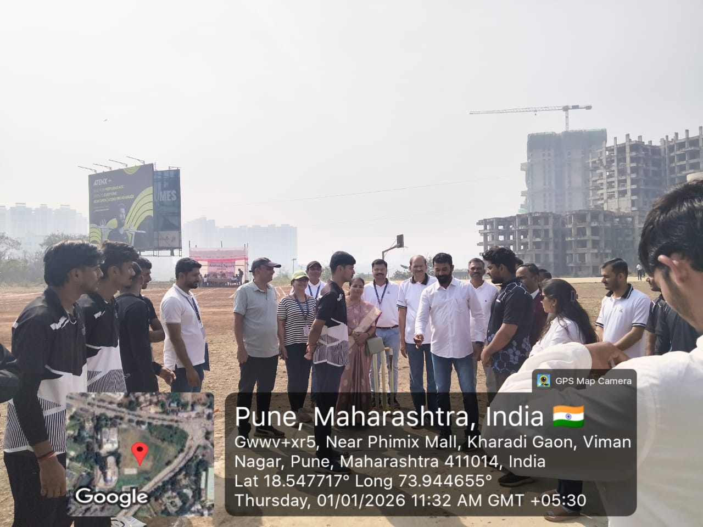
Chief guest Mr. Arvind Salve (Founder –CFC International organization, Pune) and Principal Dr. Ashok Bhosale during toss of first cricket match in between T.Y.B.Pharm Vs D.Pharm.

Dr. Vipul Dhasade Mr. Nitin Neharkar Mr. Vikram Veer
Sports Incharge Co-ordinator Co-ordinator

Dr. Ashok Bhosale
Principal


Pune District Education Association’s
Shankarrao Ursal College of Pharmaceutical Sciences and Research Centre, Kharadi, Pune-14.
------------------------------------------------------------------------------------
Glimpses of Cricket

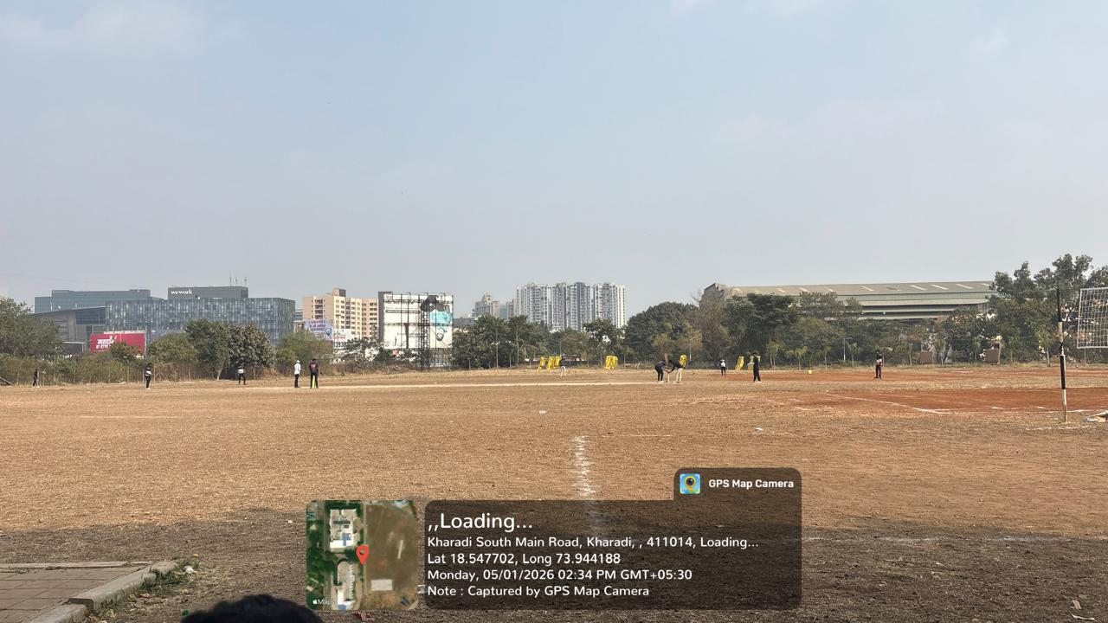
Players during first cricket match in between T.Y. B.Pharm Vs D.Pharm.

Dr. Vipul Dhasade Mr. Nitin Neharkar Mr. Vikram Veer
Sports Incharge Co-ordinator Co-ordinator

Dr. Ashok Bhosale
Principal


Pune District Education Association’s
Shankarrao Ursal College of Pharmaceutical Sciences and Research Centre, Kharadi, Pune-14.
------------------------------------------------------------------------------------
Glimpses of Cricket

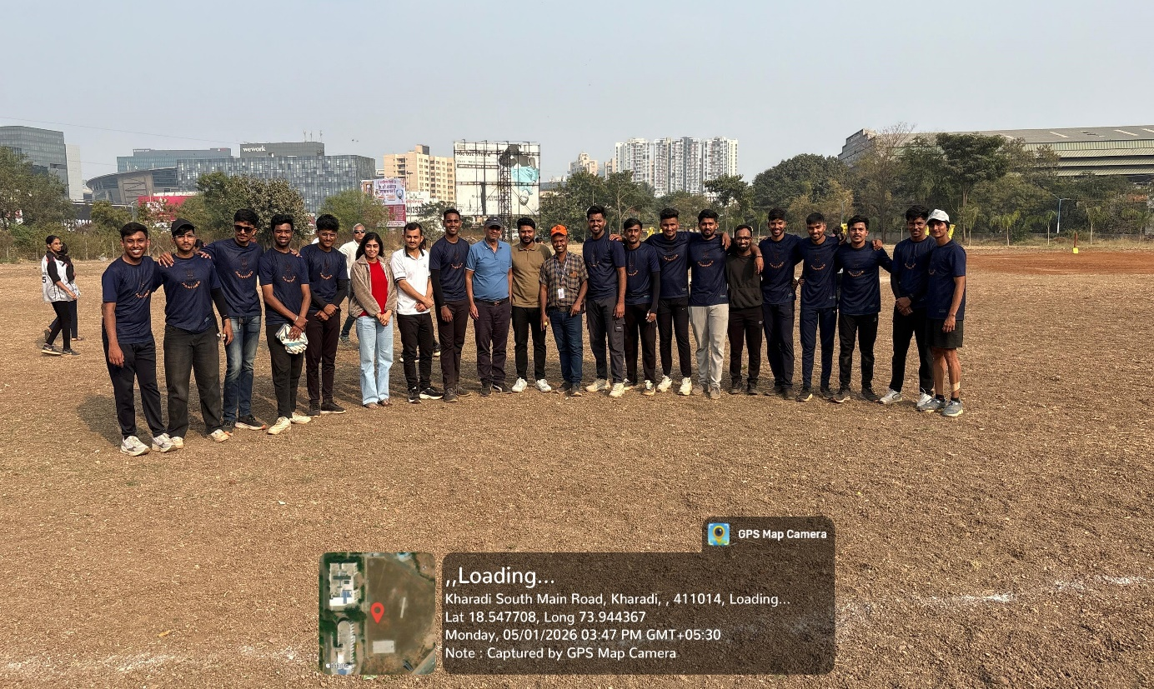
Dr. Vipul Dhasade (Sports Incharge), Prof. Vikram Veer, Prof. Nitin Neharkar (Co-orinators for boys cricket) alongwith boys cricket winner team (Final Year B.Pharm ).

Dr. Vipul Dhasade Mr. Nitin Neharkar Mr. Vikram Veer
Sports Incharge Co-ordinator Co-ordinator

Dr. Ashok Bhosale
Principal

Pune District Education Association’s
Shankarrao Ursal College of Pharmaceutical Sciences and Research Centre, Kharadi, Pune-14.
------------------------------------------------------------------------------------
Glimpses of Cricket

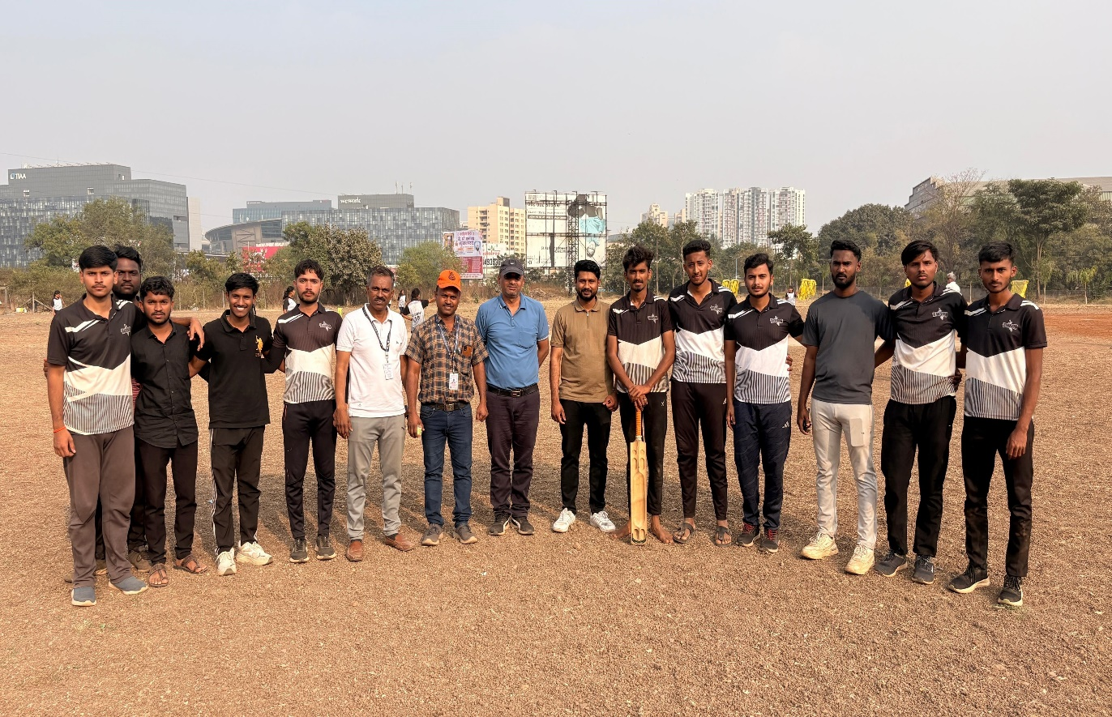
Dr. Vipul Dhasade (Sports Incharge), Prof. Vikram Veer, Prof. Nitin Neharkar (Co-orinators for boys cricket ) alongwith boys cricket runner team (Third Year B.Pharm ).

Dr. Vipul Dhasade Mr. Nitin Neharkar Mr. Vikram Veer
Sports Incharge Co-ordinator Co-ordinator

Dr. Ashok Bhosale
Principal

Pune District Education Association’s
Shankarrao Ursal College of Pharmaceutical Sciences and Research Centre, Kharadi, Pune-14.
------------------------------------------------------------------------------------
Glimpses of Cricket

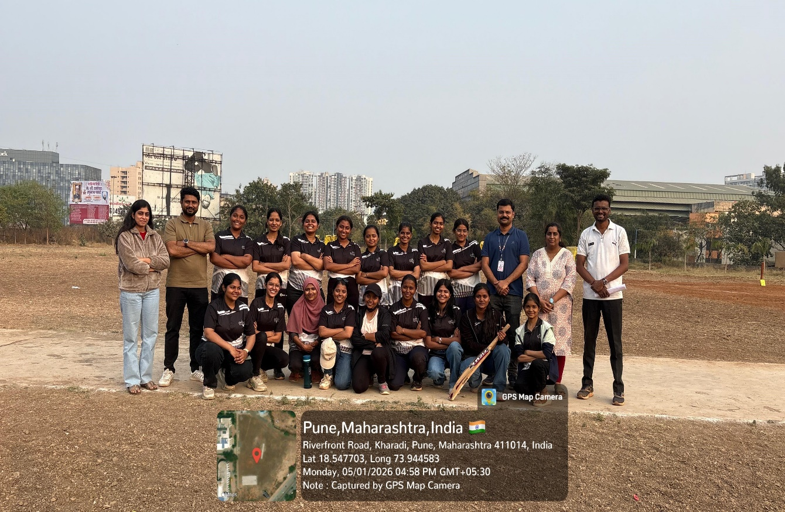
Prof. Ms. Shubhangi Karkhile (Co-orinators for girls cricket ) Prof. Nitin Neharkar (Co-orinators for boys cricket ) Dr. Sujit Kakade (HOD - Diploma in Pharmacy) alongwith girls cricket winner team (Third Year B.Pharm).

Dr. Vipul Dhasade Ms. Shubhangi Karkhile
Sports Incharge Co-ordinator

Dr. Ashok Bhosale
Principal

Pune District Education Association’s
Shankarrao Ursal College of Pharmaceutical Sciences and Research Centre, Kharadi, Pune-14.
------------------------------------------------------------------------------------
Glimpses of Cricket
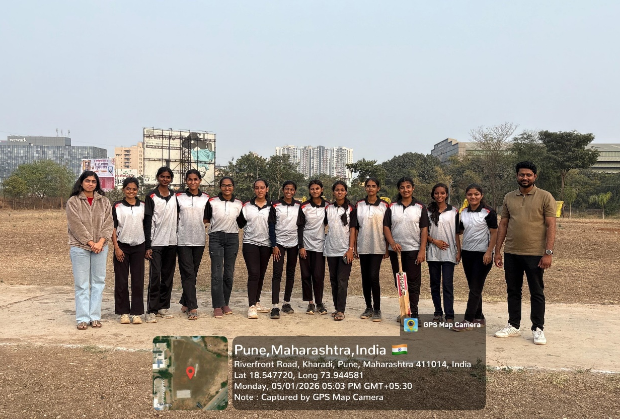
Prof. Ms. Shubhangi Karkhile (Co-orinators for girls cricket ) Prof. Nitin Neharkar
(Co-orinators for boys cricket ) alongwith girls cricket runner team (First Year B.Pharm).

Dr. Vipul Dhasade Ms. Shubhangi Karkhile
Sports Incharge Co-ordinator

Dr. Ashok Bhosale
Principal


 Pune District Education Association’s
Shankarrao Ursal College of Pharmaceutical Sciences and Research Centre, Kharadi, Pune-14.
------------------------------------------------------------------------------------
LIST OF CRICKET PLAYERS (Girls)
[Academic Year 2025-2026]

CLASS : DATE :

Sr. No. | Name | Mobile | Sign

Name & sign of Class Sports Coordinator Name & sign of Caption

